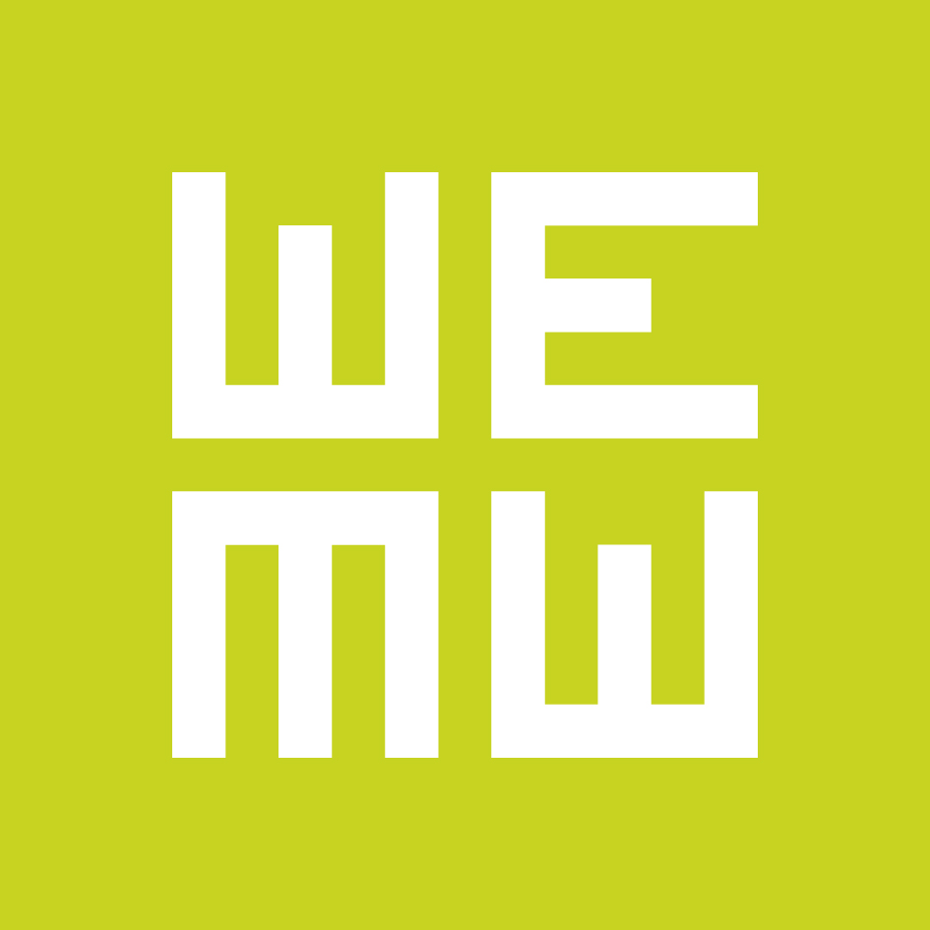

WHEN EAST MEETS WEST
call for entries for WEMW Co-production Forum and First Cut Lab

The upcoming edition of When East Meets West (Trieste - January 22-24, 2017) will have for the first time an East & West double focus, bringing together over 350 film professionals from all over Europe and, in particular, from the 2017 spotlight territories: France and the Baltic Countries (Estonia, Latvia and Lithuania).

WEMW Co-production Forum
DEADLINE: October 31, 2016
Producers from all European territories, Canada, USA and Latin America will be eligible to apply and WEMW will select 20 projects in development with co-production potential either with France, the Baltic Countries or Italy (please find more detailed info on the eligibility criteria on www.wemw.it). Projects can be long feature fiction films or documentaries with preferably 15% of the total budget already in place.
Along with the EAVE EPW 2017 scholarship, the Flow Postproduction Award and TRL Espresso, all selected projects will compete for two new prizes: the CNC Development Award, a 5.000 EUR grant for the best project, and the EWA – Europe Women’s Audiovisual Award, a cash prize for the best female director.

First Cut Lab
DEADLINE: December 5, 2016
FCL is a training programme run by Matthieu Darras and Alex Traila, and it is designed for 3 long feature fiction films in editing phase from Eastern Europe and Italy. Selected producer/director teams will receive tailor-made advice from a consulting editor (Benjamin Mirguet) and expert feedback from top international film professionals (creative producers, festival programmers, sales agents, etc). The main goal is to foster the artistic potential of selected rough cuts and, at the same time, increase the sales, festival and circulation potential of completed films. All applications must include video material not less than 60 minutes long.

More information on the submission process and the event are available at www.wemw.it
Follow us on Facebook!

